**SLF4J logging framework**

**Exercise 1: Logging Error Messages and Warning Levels**

**//TestErrorMessage.java**

package com.logging;

import org.slf4j.Logger;

import org.slf4j.LoggerFactory;

public class TestErrorMessages {

private static final Logger logger = LoggerFactory.getLogger(TestErrorMessages.class);

public static void main(String[] args) {

logger.error("This is an error message");

logger.warn("This is a warning message");

}

}

**//pom.xml**

<project xmlns="http://maven.apache.org/POM/4.0.0"

xmlns:xsi="http://www.w3.org/2001/XMLSchema-instance"

xsi:schemaLocation="http://maven.apache.org/POM/4.0.0

https://maven.apache.org/xsd/maven-4.0.0.xsd">

<modelVersion>4.0.0</modelVersion>

<groupId>Log</groupId>

<artifactId>SLF4J</artifactId>

<version>0.0.1-SNAPSHOT</version>

<dependencies>

<!-- SLF4J API -->

<dependency>

<groupId>org.slf4j</groupId>

<artifactId>slf4j-api</artifactId>

<version>1.7.30</version>

</dependency>

<!-- Logback (SLF4J Binding) -->

<dependency>

<groupId>ch.qos.logback</groupId>

<artifactId>logback-classic</artifactId>

<version>1.2.3</version>

</dependency>

</dependencies>

</project>

**OUTPUT:**

**Maven Test for TestErrorMessage:**

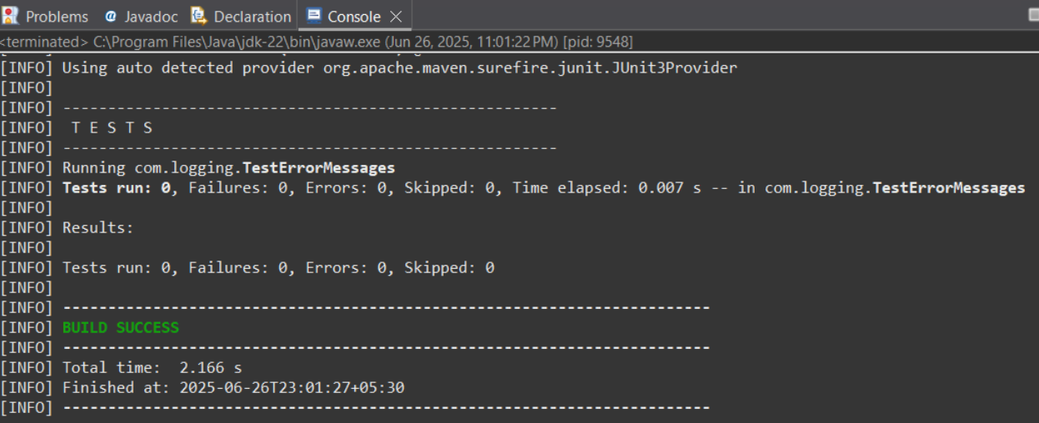

**Pom.xml:**

